MARAC STEERING COMMITTEE MEETING
JANUARY 2008
STATE CAUCUS REPRESENTATIVES’ REPORTS

DELAWARE
Delaware Public Archives
The National Endowment for the Humanities awarded a $5,000 grant to the Delaware Public Archives and the Delaware Division of Libraries to aid in the establishment of a statewide Disaster Preparedness and Recovery Planning consortium. The goal of the consortium is to protect Delaware’s material heritage by sharing resources across the member organizations. The grant money will be used to bring in a nationally-recognized disaster preparedness consultant from the California Preservation Program, a national model, to help the group develop its operational plan. The expected result of the consortium’s formation is that, in the event of a disaster, every records facility in the state would know the elements of its own plan, as well as the statewide plan, and would be ready to implement them for the safest and most successful response possible. Delaware has approximately 75 small and three mid-size archives, libraries and museums that will benefit from the proposed consortium.
Joanne Mattern, Records Services Manager, announced that she will be retiring at the end of February after a 35 year career at the Delaware Public Archives. Joanne is a charter member of MARAC, having served on the Local Arrangements Committee at the organization’s first conference in Wilmington in 1972. More recently she served on the Ad Hoc Committee on Disaster Preparedness and Response and was the Local Arrangements Chair for the Fall 2005 Dover conference.
The DPA has announced the subjects of its monthly lecture series:
February 2: “The Bayonets of the Revolution”: The Delaware Regiment in the American War for Independence by Charles Fithian.
March 1: Looking for Your French Ancestors. Ginou Berkowitch will discuss her experiences conducting genealogical research in France’s archival holdings.
April 5: How Do I Start My Family Research? Nancy Lyons, an experienced researcher and genealogist, will present a beginning genealogy program.

Hagley Library
Hagley Library will host the following special events:
February 7: Eric Schatzberg, University of Wisconsin-Madison, presents his paper “Competition and Critique: The Discourse of Technology in Twentieth-Century America” in the Copeland Room of the Hagley Library.
February 9: Black History Month Film Festival. Celebrate Black History Month at Hagley’s film festival. It will feature five films based on oral history interviews with some of Delaware’s leading African Americans.
March 6: Daniel Raff, from the University of Pennsylvania, presents “Wholesale History: Channels of Distribution and the American Book Trade Over the Long Twentieth Century.”
March 13: Carolyn de la Pena, University of California-Davis, will speak on “The Business of Diet Food: Abbott Laboratories and the Sucaryl (Cyclamates) Campaign.”
A new exhibit, “Give it your Best: Workplace Posters in the United States,” will feature more than seventy posters from the collections of the Hagley Museum and Library. The posters were printed to improve morale and bolster productivity, but are also colorful and striking examples of graphic art. The exhibit spans from 1917 through World War II. It will be open to the public from April 18 to January 4, 2009.
Winterthur
Winterthur Library recently received these important accessions:
M.B. Dyott’s Book of Patterns, ca. 1860-1865. This extraordinary hardbound catalogue contains 56 leaves that feature hand-pasted salt prints of glass lighting fixtures sold by M. B. Dyott of Philadelphia.
William Bingham Papers, ca. 1790’s. William Bingham served as consul in the West Indies and was a member of the Continental Congress, Pennsylvania state legislature, and the United States Senate. His papers consist of four series: deeds of property he owned in Philadelphia and Pennsylvania; two hand-drawn maps of his property in Kingsessing Township, now part of Philadelphia; field notes made by John Adlum and John Brodhead for Bingham-owned lands in Pennsylvania; and his own account book from the 1790s.
Respectfully Submitted,
Randy L. Goss, Delaware Caucus Representative
MARYLAND
Lewis J. Ort Library, Frostburg State University - Special Collections
A recycling exhibit was presented in conjunction with Focus Nation and the Green Initiative at Frostburg State University. Details should be forthcoming for an update at the SC meeting.
Maryland State Archives
The State Archives is extending the period for public comment for proposed State Archives Regulation COMAR 14.18.06 - Government Publications to May 1, 2008. The text of the proposed regulation can be found in the September 14, 2007 issue of the Maryland Register. A Public Meeting will be scheduled for after the comment period. Notice of this Public Meeting will be published in the Maryland Register. Comments should be submitted by email to Christine Alvey (christia@mdarchives.state.md.us) or by traditional mail: Maryland State Archives, 350 Rowe Boulevard, Annapolis, MD 21401.
The Archives is in the process of reviewing and revising its Regulations, which are rules governing Archives' policies and practices. Information about regulations being reviewed and an opportunity for public comment are at: http://www.msa.md.gov/msa/intromsa/html/regs.html
The "Important Announcements" section of the MSA website also notes that due to budget cuts and staff reductions, their hours of operations have been reduced, and they will no longer accept reference inquiries and document requests by telephone. All requests must be submitted by mail, fax, or email.
Montgomery County Historical Society - Special Collections
After months of wrangling with lawyers of the Gazette Newspapers' parent company, the Montgomery County Historical Society (MCHS) now has permission to begin digitization of the newspaper archives of The Gazette. This collection comprises the publisher's archive of all the local issues of The Gazette newspapers from the 1960's through 2002, and some predecessor newspapers companies dating back to the 1940's. The project will be a collaborative effort between MCHS, the Montgomery County Department of Corrections, and the Montgomery County Department of Technical Services. As the nearly 400 c.f. of newspapers are digitized, they will also be indexed for full-text searching.
University of Maryland [College Park] - Special Collections
Visitors to the University of Maryland’s Hornbake Library in the spring of 2008 have an opportunity to experience, first-hand, the history and artistry of 19th-century book binding through the exhibit, The Well-Dressed Book: Cloth Book Binding in the United States 1830-1920. Assembled by a curatorial team from the Libraries and based on the holdings of Special Collections in Hornbake Library, this exhibit explores many aspects of 19th-century bindings. The exhibition is on display from February 4, 2008 through June 30, 2008 in the Maryland Room Gallery in Hornbake Library. For more information please visit http://www.lib.umd.edu/mdrm/gallery/
In conjunction with the exhibit, the Hornbake Library will be sponsoring The Well-Dressed Book: A Symposium on Nineteenth-Century American Cloth Binding on March 14, 2008. This will be a day long symposium featuring scholars, curators, and collectors exploring cloth publishers’ bindings in nineteenth-century America. Scheduled speakers include: Michael Winship, Sue Allen, Steven Beare, Jessica Lacher-Feldman, Douglas McElrath and Randy Silverman. Registration information is available at: http://lib.umd.edu/bindings For additional details please call Douglas McElrath at 301-405-9210.
Susan Schreibman, Assistant Dean and Head of Digital Collections and Research (DCR) at the University of Maryland Libraries will be taking a ten-month leave of absence to serve as Director – Digital Humanities Observatory at the Royal Irish Academy. In her absence, Jennie A. Levine (Archives and Manuscripts) and David Kennedy (Information Technology Division) have agreed to co-manage DCR through the end of 2008. The Office of Digital Collections and Research (DCR) of the University of Maryland Libraries (http://www.lib.umd.edu/digital/) supports the teaching and research mission of the university by facilitating access to digital collections, information, and knowledge. This is accomplished through enhancing access to selected library resources through the development, maintenance, and preservation of digital collections; by serving as a knowledge resource within the university for digital library issues and development; by participating in national and international initiatives which further the development of new forms of scholarly communication, tools, standards, and applications; and by providing training and support in digital library standards and formats.
Respectfully submitted,
Rob Jenson, Maryland Caucus Representative
NEW JERSEY
News from New Jersey State Archives, Trenton, January 2008:

Joseph R. Klett, Chief of Archives, reports that William T. Black Jr. has donated an incredible treasure of family papers, maps, and Burlington County tax and militia records to New Jersey State Archives. This cache of manuscripts, spanning three centuries, was preserved and passed down through the generations of the donor’s family. The donation includes parchment indentures and estate papers from 1684-1845, business ledgers from 1776-1904, official records of Burlington County Tax Collector John Black from 1781-1813, a small collection of militia papers from 1797-1804, and maps and drawings from as early as 1780. The State Archives frequently redirects potential donations of family papers to other repositories. However, in this case, the collection included important 18th- and early-19th-century government papers and numerous colonial-period land records. Among the taxation records, for example, are several hitherto unknown Burlington County tax ratable lists from the late 1700s. Given the nature of the material and how it relates to records already in the State Archives, accepting the collection was an easy decision. Janet Jackson, under the supervision of Collection Manager Ellen Callahan, is describing and arranging the collection. A preliminary inventory is available in the State Archives’ Manuscript Reading Room.

There have been many recent developments on the State Archives’ expanding website. High on the list of improvements is a far more powerful search engine for online databases, developed by Archivist Vivian Thiele. Website users can now enjoy much faster searches and can also sort the results by field. Reaching this milestone now allows the State Archives to focus its efforts on posting new data. Check out the new search engines here:

http://www.njarchives.org/links/databases.html

The site now includes these databases:

New Jersey Marriages, 1666-1799 (11,500+ records)
New Jersey Marriages, 1848-1867 (74,500 records)
Supreme Court Case Files, 1704-1844 (54,500+ records)
Passaic County and Atlantic City returns, 1885 State Census (nearly 70,000 records)
Name-Change Judgments (statewide), 1847-1947 (46,000 records)

The Archives has also added a number of imaged collections to its site, including:

Hunterdon County Slave Manumissions, 1788-1836
http://www.njarchives.org/links/guides/chncl003.html

Oaths of Office of Governors and Acting Governors, 1790-2006
http://www.njarchives.org/links/guides/sstse007.html

Evidence Photographs from the Hauptmann Trial (Lindbergh Kidnapping), 1935
http://www.njarchives.org/links/guides/slcsp001.html

Governor’s War Cabinet Minutes, 1942-1944
http://www.njarchives.org/links/guides/szwaa001.html

Bruno Richard Hauptmann Inmate File, 1934-1965
http://www.njarchives.org/links/guides/sintr003.html

Grover Cleveland Family Records, 1838-ca. 1909
http://www.njarchives.org/links/guides/pclev001.html

The State Archives has also expanded its “Documentary Treasures” site. A new area celebrates New Jersey’s original federal charters and their recent digitization, and also presents the minutes of the State’s 1787 ratification convention and legislative actions (ratification or otherwise) relative to the 27 federal constitutional amendments. Check out the 170 new web-pages starting here:

http://www.njarchives.org/links/treasures/usconstitutionmenu.html

In addition, the Archives unveiled a new site exhibiting King George III’s 1762 commission of William Franklin as the last royal governor of the Colony of New Jersey here:

http://www.njarchives.org/links/treasures/oaths/franklin.html

These new web resources were developed by the State Archives’ Publications Unit supervised by Archivist Veronica L. Calder under the direction of Mr. Klett.

The Historic Maps Collection of Princeton University’s Rare Books and Special Collections Department has received funding from the New Jersey Historical Society to help complete the digitization of its collection of historic Sanborn fire insurance maps of New Jersey. Five counties are essentially done—Atlantic, Burlington, Hunterdon, Mercer, Monmouth—and that progress over time can be checked at:

http://libweb.princeton.edu/libraries/firestone/rbsc/aids/sanborn/sanborn-web.xls

The digitized maps are viewable over the web from that spreadsheet. Copyrighted maps, of course—those published after 1922—must still be viewed in person at the Department.

John Delaney, Curator
Historic Maps Collection
Princeton University Library
One Washington Road
Princeton, NJ 08544
phone: 609-258-6156
fax: 609-258-2324

Seton Hall University

Various collections continue to be acquired on a regular basis as part of an ongoing mission to enhance institutional history resources. The first major grouping of Irish-American papers obtained by our repository were donated by former New Jersey State Ancient Order of Hibernians Chair James McFarland. This documentation centers upon varying issues that range from AOH activities within the Garden State to the peace process in Northern Ireland. A majority of these papers, reports and related items were produced during the 1980s-90s.

A special window exhibit entitled: "Essex Catholic High School on Broadway, 1957-2003" celebrating this defunct preparatory school was on display from October 2007- January of 2008 at Walsh Library on the campus of Seton Hall University. The showcase featured various yearbooks, prints, trophies and other memorabilia from, and about this particular institution. A number of former ECHS Eagles provided items with a large concentration coming from Tom Murray, former History Teacher and show co-curator who donated many of his own professional effects to our school in conjunction with this event.

Counted among the most important additions to the Homepage include the processed finding aid for the Papers of William T. and Marie J. Henderson Collection (1930-89). The Hendersons were local civic leaders and benefactors of the school who were involved in many religious organizations around the Northern New Jersey region.

Various updates to our Homepage have been made over the past few months including a new site that links various visual and digital-centered projects that our repository is involved with at the present time. This particular page includes on-campus, local South Orange community preservation events and different ecumenical-based affiliations. The whole Homepage can be viewed via the following link - http://library.shu.edu/sc-homepage.htm

Submitted by Alan Delozier, Director & University Archivist

News from Newark Public Library Special Collections

Recent acquisitions
Collection of prints from noted New York printmaker and illustrator John Ross including: Penn Station, Fontezza, Refinery, Vertical Forces and Vortex as well as four artist proofs from his Venetian Carnival series: Banta, Columbine, Doctor of the Plague, and Fisherman.
John Ross also donated a copy of his fine illustrated book, Birds of Manhattan (High Tide Press, 1998). A copy is displayed on the web site of the AIGA Design Archives: http://designarchives.ws1.hq.aiga.org/entry.cfm/eid_1369.

Collection move
As part of an effort to provide new, climate-controlled space for its collections, the move of several significant collections to a new off-site storage area in Newark was completed this past November. The Richard C. Jenkinson Collection of over 3,600 titles of fine press books and the history of fine printing, the Wilbur Macy Stone Collection of children’s literature, the Floy McEwen Collection of Christmas books and the Library’s Rare Book Collection of over 3,000 titles were among those collections re-located.

Exhibition
The Eighth Exhibition of Shopping Bags: Infinite Commercial Art Designs Adorning a Practical Function, Jan. 23-Mar. 16, 2008, Third Floor Gallery, Newark Public Library.
The Exhibition features miniature bags, historic Bloomingdale’s Department Store bags, bags for celebrated artists, bags from Newark and New Jersey as well as bags from all over including London, Paris, Rome and the Pacific Rim all from the collection in the Special Collections Division of the Newark Public Library. For more information, contact the Special Collections Dept. (http://www.npl.org/Pages/Collections/specialcollections1.html).

Chad Leinaweaver
Special Collections Division, Newark Public Library
5 Washington Street
PO Box 630
Newark, NJ 07101-0630
(973) 733-7745
cleinaweaver@npl.org
http://www.npl.org/Pages/Collections/specialcollections1.html

Cape May County Clerk Rita Marie Fulginiti was honored October 13 by the Mid-Atlantic Regional Archives New Jersey Caucus for her leadership over the Cape May County Clerk’s Archival Records Program. The Archives Program was praised for excellence in preservation of the collection, which dates back to 1692. Rita Marie accepted the group’s Institutional Award for Excellence from Gary Saretzky during the Archives and History Day celebration hosted by the Monmouth County Archives and Records Center. Archivist Diana L. Hevener was recognized by County Clerk Rita Marie Fulginiti for her role in overseeing the County Clerk’s Archives Program which was cited for it’s commitment to conserving historical records and for innovations in preserving records through technology.

In October, the Cape May County Clerk, Rita Marie Fulginiti hosted a workshop and presentation by local Historian Michael Conley of Dennisville and cemetery Historian Alex Bennett of Lower Township, which concluded with a walking tour of the First Baptist Church Cemetery led by church Historian Susan Armour. All attendees were invited back to the County Clerk’s Hall of Records for a small class in Records Research given by Michael Conley and Diana Hevener.

The Cape May County Board of Chosen Freeholders and Cape May County Clerk Rita Marie Fulginiti officially opened the County’s New Records Recovery Center on Thursday, November 1, 2007. Karl Niederer, Director of the Division of Archives and Records Management presented the County with the PARIS Award for Excellence for Disaster Preparedness during the ceremony.

Diana L. Hevener
Private Clerk / Records Manager
Cape May County Clerk's Office
(609) 463-6448
(609) 465-1022 fax

Nicole DiRado, Clerk of the Union County Board of Chosen Freeholders, accepted the award for Outstanding County Project Management at the first annual PARIS Awards for Excellence in Trenton on October 10. Dr. Allen Weinstein, Archivist of the United States, addressed the overflow audience of county officials and guests in the General Assembly Chamber at the State capitol. In presenting the award, DARM director Karl Niederer commended Union County for committing to a long-term records management program, and encouraging its municipalities to participate in the grant program.

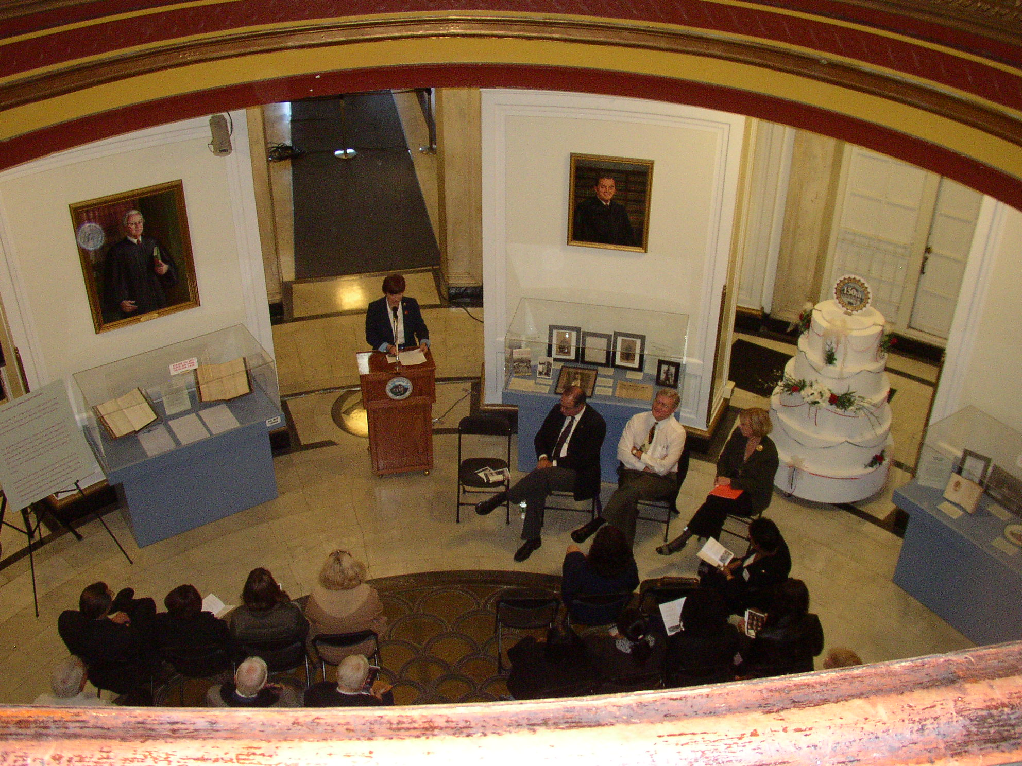
Union County drew the curtain on its sesquicentennial year on October 29 in the rotunda of the County Courthouse in Elizabeth. Freeholder Chairwoman Bette Jane Kowalski greeted more than sixty guests, and introduced County Clerk Joanne Rajoppi, and Karl Niederer, director of the New Jersey Division of Archives and Records Management. Ms. Rajoppi spoke about the history of the courthouse and its treasures, including hidden frescoes on the rotunda ceiling. Karl Niederer emphasized the importance of the PARIS grant program in preserving the documentary history of the counties and municipalities in New Jersey. An exhibition of historic Union County documents and photographs which were preserved with PARIS support, accompanied the event. The exhibition included reproductions of three pages of the March 1857 Act creating Union County.

Freeholder Chairwoman Bette Jane Kowalski closes the 150th Anniversary of Union County. Freeholder Vice Chair Angel Estrada, NJ-DARM Director Karl Niederer, and Joanne Rajoppi, Union County Clerk, wait to address the audience.

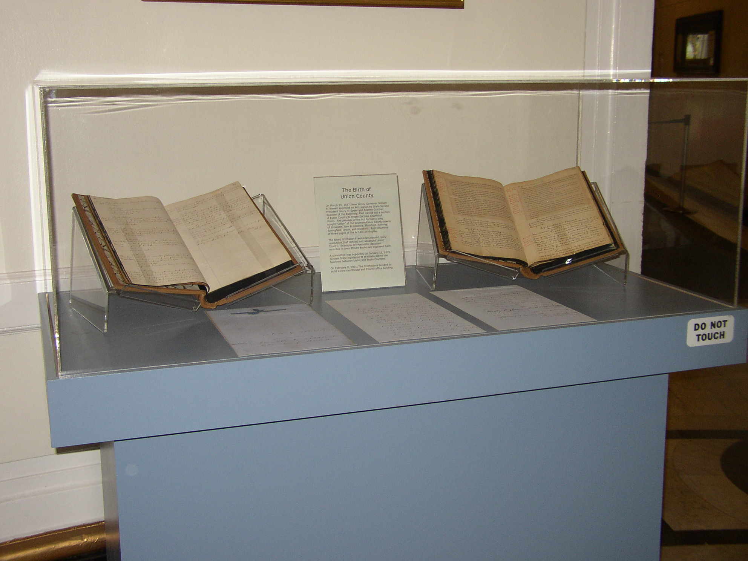
Birth of a County. Part of the exhibit included reproductions of the 1857 Act establishing Union County, NJ, and two nineteenth century Freeholder Board minute books.

John Celardo
Archivist
Union County, NJ

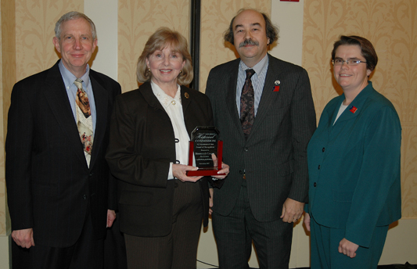
The Monmouth County Archives received an Award of Recognition from the New Jersey Historical Commission (NJHC) at its annual conference on November 17, 2007. In presenting the award, the Commission stated: "Since opening to the public in 1994, the Archives has been a model for other New Jersey counties. With over 75 collections comprising approximately 6,000 cubic feet of historical records, and with a research room able to accommodate a dozen researchers, the Archives provides services to more than 1,000 researchers annually. Guides and detailed indexes facilitate information retrieval, including several databases on its website, which was a recipient of a Finding Aid Award from MARAC. The Archives has preserved its collections through professional conservation of its most valuable records dating back to the 17th century, and through the microfilming of approximately 14 million pages of documents. The Monmouth County Archives promotes knowledge of archival resources and New Jersey history through Archives and History Day, an annual public event, begun in 1996, in which approximately 70 history organizations and 300 people participate." Monmouth County Clerk M. Claire French and Archivist Gary D. Saretzky accepted the award from NJHC Director Marc Mappen and Commission member Catherine Cassidy of Bergen County.

Gary D. Saretzky
Archivist, County of Monmouth

The Harrison A. Williams, Jr. Papers project at Rutgers University, originally funded for two years through the end of 2007, has been extended to June 30, 2008. Williams represented New Jersey in the U.S. Senate from 1959 until 1982. He also served in the House of Representatives from 1953 through 1956. Initially totaling over 2000 cubic feet, the collection was formally donated by the late Williams’s wife in 2005 to Rutgers, where the papers had been held since his resignation from the Senate.

Staffed by two full-time archivists, the Williams project has completed to date over 1400 cubic feet, of which 650 cubic feet were retained, 200 cubic feet of Committee records were returned to the Senate, and 550 cubic feet were discarded. An EAD inventory of the processed papers, including container lists for over 21,000 folders, is nearing completion for public access in January 2008. Constituent correspondence, project files, case files, and much of the legislative files comprised the principal focus of work for the project’s first two years.

The collection holds rich material on a tremendously wide variety of international, national, regional, and New Jersey subjects of research interest. Accordingly, a key processing strategy has been the identification of expanded folder-level descriptions and subject terms for select series in order to facilitate research by local historians, undergraduates, and other users unaccustomed to navigating large Congressional collections.

Larry Weimer
Archivist
Special Collections and University Archives
Rutgers University

Online Access to All Collections at Princeton's Mudd Manuscript Library

Staff at the Seeley G. Mudd Manuscript Library at Princeton University have recently completed a project aimed at providing online access to all of the Mudd Library’s collections, both processed and unprocessed.

In addition to a number of ambitious processing projects, in the fall of 2006 the library began a retro-conversion project, resulting in the conversion of all legacy electronic finding aids to Encoded Archival Description. Collection-level MARC cataloging was completed for all collections lacking finding aids, and the MARC records were then converted to EAD, primarily through the use of XSL stylesheets and Terry Reese’s MarcEdit software. With the new EAD finding aids, descriptive records, at least the collection level, for all of Mudd’s collections are discoverable in the Princeton University Library’s OPAC, the Department of Rare Books and Special Collection’s EAD website, union catalogs and databases such as OCLC’s WorldCat and ArchiveGrid, and via common internet search engines such as Google and Yahoo. As of November 2007, 478 records for Mudd Library collections are available.

Staff will continue to add to the collection-level records through the creation of series, box, or file-level inventories. The Mudd Library is also currently revising accessioning procedures in order to ensure that both collection-level MARC records and EAD finding aids are produced at the time of accessioning. We also plan to increasingly link finding aids to digital surrogates of material in collections and to explore additional ways for users to interact with finding aids and the material that they represent.
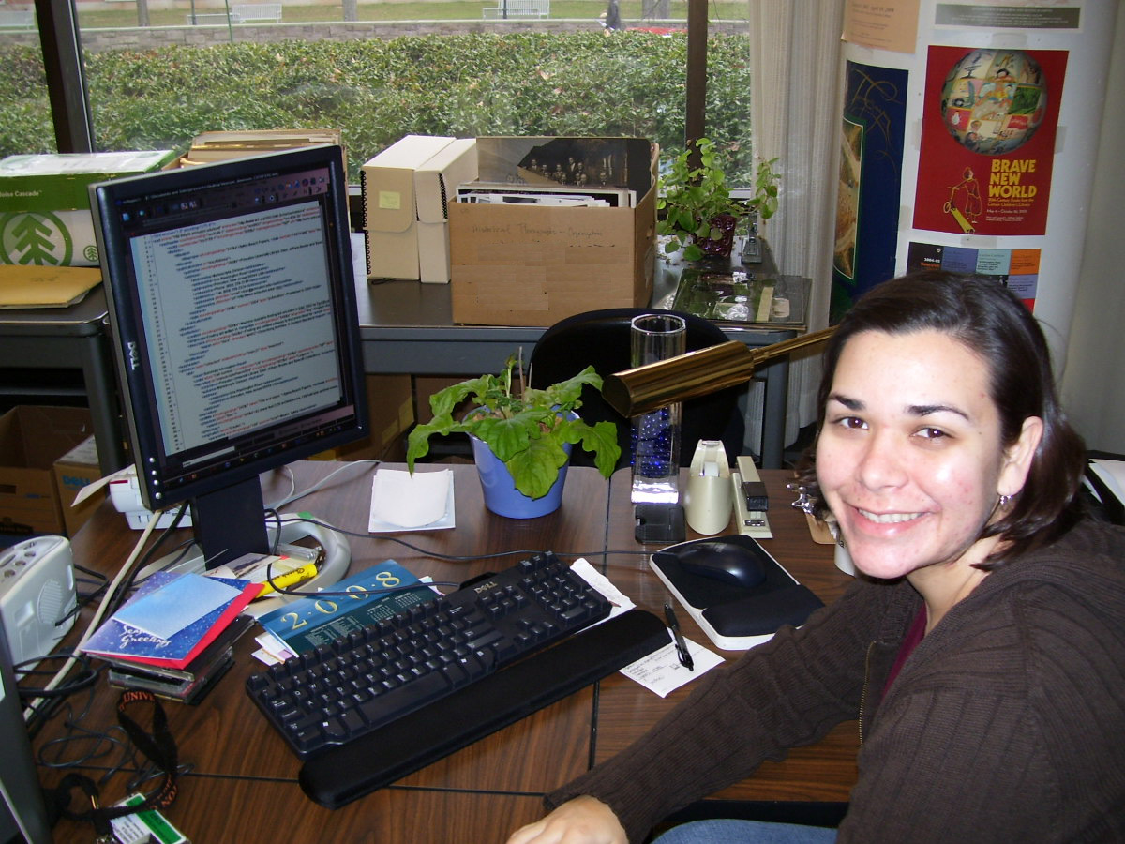
The project, led by Dan Santamaria, Assistant University Archivist for Technical Services, was a team effort by processing and technical services staff at the Mudd Library. Cristela Garcia-Spitz (see photo) managed the retro-conversion portion of the work which resulted in the encoding of several hundred finding aids, while other Mudd staff, Adriane Hanson, Christopher Shannon, Jennie Cole, and Casey Babcock created new finding aids and MARC records. Christie Lutz and Dan Brennan created hundreds of MARC records for Princeton University Archives collections and converted the records from MARC to EAD.

For additional information please visit the Princeton University Library’s Department of Rare Books and Special Collections Finding Aids website at: http://diglib.princeton.edu/ead or contact Dan Santamaria (dsantam@princeton.edu).

Mudd Manuscript Library creates blog

Keep abreast of what is happening at the Mudd Manuscript Library by visiting our blog at: http://blogs.princeton.edu/mudd/ You can read up on news about acquisitions, new finding aids, interesting reference questions, and staff and professional activities.

Princeton economics processing project completed: More than 1,100 feet of records providing insights into 20th-century economics history available

Princeton University’s Seeley G. Mudd Manuscript Library has completed a two-year project to process all of its economics-related public policy collections to modern standards. These collections provide a rich resource about American economic thought and policies in the 20th century and the impact of American economic policy and the ideas of some of the leading economic thinkers on the emerging world economy, especially in developing nations.
Twenty-eight collections, totaling more than 1,100 linear feet, were processed through the support of the John Foster and Janet Avery Dulles Fund and a grant from the National Historical Publications and Records Commission. Electronic finding aids for each collection are available on the library’s website for researchers. (http://diglib.princeton.edu/ead/index.html)

The collections as a whole document economic activity that spans the globe, including every settled continent. The main subjects documented by the papers are public and international finance, economic development and economic policy, as well as monetary policy, policies during World War I and II, business history and demography. These records provide insight into the economic debates that thrived during the 20th century: the establishment or disavowal of the gold standard; international monetary policy and free trade; the various approaches to what was called Third World development (including population control); and means to alleviate depression and/or inflation. In a time when free market ideas are ascendant, these collections bear testament that the path was neither linear nor smooth.
The collections document both the theory and practical application of economics and include the papers of scholars, U.S. government officials, advisers to governments throughout the world, bankers, lawyers, business leaders, a policy advocacy group, and organizations devoted to economic development. Among the important collections are the papers of Edwin W. Kemmerer, adviser to many countries on monetary policy during the 1920s; Jacob Viner, one of the most prominent economic scholars of the 20th century; Nobel Laureate W. Arthur Lewis; and Albert O. Hirschman, a leading scholar in the field of economic development. Kemmerer, Viner and Lewis were members of the Princeton faculty, while Hirschman was at the Institute for Advanced Study.

Records of prominent organizations were also processed as part of the project, including those of the Development and Resources Corporation, a for-profit concern involved in economic development around the world, such as a substantial project in Iran; Women’s World Banking, a nonprofit international financial institution that facilitates the participation of women entrepreneurs in the modern economy; and the Economists’ National Committee on Monetary Policy, an advocacy group for monetary policy, especially for the gold standard, in the United States.

The project began in October 2005 with the hiring of project archivist Adriane Hanson to oversee the work on the 28 collections. She was joined in January 2006 by special collections assistant Christopher Shannon and a small group of student assistants. In two years, the team arranged and rehoused all 28 collections, ranging in size from one box to 450 boxes. Hanson wrote finding aids and catalog records for each of the collections, which are now available online to aid researchers in discovering and utilizing these resources.

Daniel J. Linke
University Archivist and Curator of Public Policy Papers
Seeley G. Mudd Manuscript Library
Princeton University
65 Olden Street
Princeton, NJ 08540
609-258-6345
609-258-3385 (fax)
http://www.princeton.edu/mudd/

The David Sarnoff Library continues to promote itself and its archival and artifactual collections through a variety of events and activities. After hosting another successful re-enactment of Orson Welles's War of the Worlds broadcast in October, it was the site of an engrossing multimedia electronic music concert on December 15. Visitors at both events took in the museum during intermission or before the shows.

In the archives, Dr. Sheldon Hochheiser is volunteering his time once a week to process the papers of Dr. Jan Rajchman. Co-inventor of computer memory; his collection runs from the 1940s into the early 1970s and documents the development of computer memories.
Volunteer Vrinda Kaimal finished converting a 20-year-old dot-matrix printed index comprising 61 single-spaced pages of RCA broadcast manuals, 1930-84, to a spreadsheet. This accomplishment will enable the Library to begin cataloging the actual manuals recovered from last spring's flood.

At the Library's website, davidsarnoff.org, among the RCA Texts of the Library Online, the memoirs of Harry and Raymond Sooy are now available. The Sooys led the Victor Talking Machine Company's Recording Department in Camden from 1898 to 1931, and their recollections, based apparently on diaries, are a compendium of recording dates, locales, techniques, and incidents with opera and popular performers. All thanks are due to volunteers Ann Marie Toner and especially Janet Swartz for editing the OCR scans of the "original" photocopies.

Over the last three months the Library has hosted six researchers from Lafayette College, Princeton and Rutgers Universities. It has also assisted with an average of two inquiries a day, on everything from electron microscopy and the origins of nanotechnology to a documentary on color television.

The research has spurred several new accessions, especially in electron microscopy. Thanks to the gifts of the children of John Reisner and Robert Hillier, the Library has just received six linear feet of James Hillier's papers, and six more comprising the John Reisner Collection, which volunteer Vrinda Kaimal has begun processing. Together these collections document the origins of electron microscopy outside Germany from before World War II to the late 1960s.

The Library also welcomes Rutgers public history intern Philip Lee, who will assist in the improvement of exhibit displays and their website versions during the spring semester.
Alexander B. Magoun, Ph.D.
Executive Director
David Sarnoff Library
201 Washington Road
Princeton NJ 08540-6449
609-734-2636
amagoun@davidsarnoff.org
(f) 609-734-2339
www.davidsarnoff.org
www.davidsarnoff.blogspot.com

The New Jersey Library Association, History and Preservation Section is sponsoring three programs at the NJLA Annual Conference, April 30 - May 1, 2008 at the Ocean Place Resort in Long Branch, NJ.

1--Thursday, May 1, 2008 11:30AM - 12:20PM “Reference Use of Congressional Papers in New Jersey Local History Research”

Speaker - Larry Weimer, Project Archivist Special Collections and University Archives, Rutgers University Libraries

Program text: Collections of the papers of U.S. Senators and Congressmen/women are commonly recognized for their importance in research of Federal legislative matters. Less appreciated is the value of these collections for local and social history. Drawing principally on the papers of former U.S. Senator Harrison A. Williams, this session explores the ways in which reference librarians can assist local researchers in the use of Congressional collections.

2--Wednesday, April 30th, 2008 3:30PM to 5:20 PM (Double Session) "Oral History Programs in our Public Libraries: Presenting and Preserving our Local Heritage"

Speakers - Part One
Joe Da Rold, Director, Plainfield Public Library Michael Brigham, Project Coordinator, StoryCorps Part Two Cheryl C. Turkington, Assistant Archivist, Morristown and Morris Township Library, North Jersey History Center Bob Golon, Assistant Library Director, Plainfield Public Library

Program Text: Donald A. Ritchie, in his book Doing Oral History: A Practical Guide explains that, “Oral history collects memories and personal commentaries of historical significance through recorded interviews.”
Part one of this session focuses on the successful collaboration between the Plainfield Public Library and StoryCorps, using a new approach to oral history to document the personal histories of the local African-American and Latino communities. Part two focuses on planning tools and technical issues that must be considered by the library to assure a successful oral history interview project.

3--Wednesday, April 30th, 2008, 1:30PM - 2:20PM "Trash or Treasure? To Fix or Not to Fix? Topics for “Tough Love” in Collection Development"

Speakers: Chad Leinaweaver
Special Collections, Newark Public Library Tim Corlis Head of Preservation Special Collections and University Archives, Rutgers University Libraries

Program Text: Collection development involves more than just bringing in the latest releases and weeding out the non-circulating titles. Many libraries have “buried treasures,” rare or unique items that remain in storage or on the circulating shelves, because we aren’t certain how to handle them. What can a library staff do when faced with multiple items, from books to maps to images, in various conditions? How do we prioritize what should be repaired and what should be discarded? How do we identify and handle materials that might have special value due to rarity? This session helps librarians to spot the items that need special care, identify items of special value, prioritize the needs of the items and employ preservation strategies.

MARAC member Bob Golon has a new book coming out in March entitled "No Minor Accomplishment: The Revival of New Jersey Professional Baseball." For more information on it, see the Rutgers University Press catalog page: http://rutgerspress.rutgers.edu/acatalog/No_Minor_Accomplishment.html

Respectfully submitted,
Daniel Linke, New Jersey Caucus Representative
NEW YORK
Sister Margaret Ahl, Provincial Archivist for the Northeast Province of the Daughters of Charity
Daughter of Charity Sister Margaret Ahl died at DePaul Provincial House on Sunday, October 14, 2007. Margaret Catherine Ahl was born in 1923 to Mary E. Connolly and William H. Ahl in Jamaica, N.Y. Sister Margaret entered the Daughters of Charity in Emmitsburg, Md. in 1943. By 1973 she had achieved both an RN and a master's degree in nursing education, ranking number one on the state board examination that year. For the next 21 years, she served as director of three hospital-based nursing schools, Providence, Detroit, Mich., St. Vincent's, Jacksonville, Fla. and Catherine Laboure in Boston, Mass. By 1972, Catherine Laboure School of nursing, under her leadership, had become a junior college of nursing and allied health science. Sister Margaret began studies at Boston University and achieved a doctoral degree in education in 1975. Now began the most important challenge of her life, an assignment to Bethlehem in Palestine in 1976 where she laid the foundation of a baccalaureate program in nursing for the Palestinian Arabs at Bethlehem University on the West Bank. Under unbelievable obstacles, she established the program with a small faculty and the help of United States (AID) funding and graduated the first class of eleven men and three women in 1980. The program flourished despite constant disruptions, and today enrolls over 200 students in both nursing and allied health care occupations.
Sister Margaret retired to DePaul Provincial House in Menands in 2000 where she served almost seven years as community archivist, completing her 64 years as a Daughter of Charity. She assumed her duties as Provincial Archivist for the Northeast Province of the Daughters of Charity in January 2000 after attending the Modern Archives Institute in Washington D.C. During her tenure she instituted an oral history program to document the lives of the Daughters of Charity in the Northeastern US and Canada, oversaw the transition from paper based to electronic finding-aids, and revised and updated the archives policy and procedure manual. In addition Sr Margaret researched and wrote brief biographies of ninety Daughters of Charity. The collection of biographies was printed and distributed to the community. In 2005 Sr Margaret supervised a major renovation of the Daughters of Charity Archives facilities in Albany, NY that included an expansion of the Archives offices and the addition of a dedicated processing area.
Sr Margaret was a member of several professional organizations including the Society of American Archivists, Archivist of Congregations of Women Religious, Mid-Atlantic regional Archives Conference, Archivists of Religious Institutions and Capital Area Archivists. Her vision, gentle demeanor and keen intellect will be missed by all who knew and worked with her.
Retirement of Phil Maples
Phil Maples, the long-time Curator and Archivist of the ViaHealth Archives Consortium, is retiring after 31 years at Rochester General Hospital, leaving a legacy of service to the hospital and community that will be remembered for decades. Phil first came to Rochester General in 1976 as a security guard. With a life long interest and a graduate degree in History, Phil joined the Archives Committee in 1977 and six years later was appointed as the archivist of the Baker-Cederberg Archives in August 1983. Over the next twenty-four years, he transformed the collection of documents, books, photographs and artifacts into an internationally known and widely respected medical museum and archives. His steadfast advocacy for the preservation of this important historical material as well as his skillful leadership over the years in the development of numerous exhibits, programs, and projects promoting the hospital’s and affiliated organizations’ proud history have prepared the Archives for the opportunities and challenges of the future.
Under Phil’s guidance, the archives began a series of operational and organizational improvements that developed the collections and their usefulness to the hospital staff and the local community. In August 1983, Phil was appointed as the Archivist of the Baker-Cederberg Archives, and aided by a loyal team of volunteers, began to catalogue and arrange the extensive collections. In addition to the fundamental management of the collections, Phil concentrated on developing education exhibits, community outreach projects, an oral history program, and the development of the membership association, The Heritage Society. In addition to the collections of Rochester General and The Genesee Hospitals, as well as their nursing schools, Phil also oversaw the addition of close to two dozen repository collections are now housed at the Archives.
The ViaHealth Archives Consortium’s grand opening on March 15, 2005 in the newly remodeled 6,000 square foot archives and museum was a milestone and a life long aspiration of Phil’s. Under Phil’s able leadership, the Archives now encompass two museum galleries displaying eighteen exhibits on an array of aspects of the hospitals or an affiliated organization’s history. In addition, the new archives vault is a 3,000 square foot repository for the archives and material culture and has separate rooms for the Behavior Health Network and Society for Total Emergency Programs (STEP) Collections as well as six state of the art moveable storage shelves. This new Archives and Museum space has come about in no small part because of Phil Maples’ dedication and steadfast devotion to preserving this valuable history and will remain in the future as a testament to his tenure as the Director of the ViaHealth Archive Consortium.
- Bob Dickson and Kathleen Britton
Geri Solomon reports that the “Special Collections at Hofstra University are moving to newly renovated quarters in the Axinn Library Lower Level. We will have two stack areas, a rare books compact shelving area and an archival stacks area with processing room. Our phone number and e-mail addresses remain the same. We are looking forward to being back on campus again after 16 years – 1/2 mile west of the main campus!”
Respectfully submitted,
Raymond LaFever, New York Caucus Representative
PENNSYLVANIA
The PA Caucus website was recently updated to include new institutions and their website as well as updating links to existing institutions.
Luzerne County Historical Society
The Luzerne County Historical Society is celebrating its 150th anniversary in 2008. This Society, the oldest county historical society in Pennsylvania, is planning a number of special events to be held during the year. The Kick-Off will be held on February 11, the actual birthday of LCHS. There will be the Annual Meeting in April, a Gala Ball in June and a Fall Festival in September.
Also, during the year an exhibit will be on display at the LCHS Museum entitled "150 Treasures for 150 Years." This exhibit will include the "best" 150 items in the Society's collection. These items will include artifacts, photographs, maps, documents, and books.
Bucknell University
Doris Dysinger, Curator, Special Collections/University Archives at the Bertrand Library, Bucknell University will retire in April 2008 after 25 years as curator. Her replacement will be Isabella O’Neill, also a long-time employee of Bucknell whose background is in coordinating several public services areas for the Bertrand Library. We wish to thank Doris for her hard work and the significant advances she initiated for special collections and archives at Bucknell.
The Pennsylvania State University
The Pennsylvania State University Special Collections Library received a $15,000 matching grant for 2008/2009, written by Susan Hamburger and Sandra K. Stelts, to process the Kliegl Bros. and Century Strand Co. theatre lighting original pencil, ink, and blueprint drawings (contained within 66 flat file drawers) documenting the late twentieth-century innovations in theatre lighting equipment installed in public spaces (theatres, auditoriums) in academic and public institutions in Pennsylvania and throughout the United States.
From establishment in 1896 until dissolution during the 1990s, the Kliegl Brothers was the oldest and largest stage lighting manufacturer in the world. The carbon arc lamps used in the lighting of motion picture sets since the silent film era were originally called Kliegl lights after their inventors, the brothers John and Anton Kliegl, and later shortened to Klieg lights-the preferred standard in stage as well as screen production since 1911. The brothers emigrated from Germany to America in the 1880s, launched the Kliegl Brothers Universal Electric Stage Lighting Company in 1896, and shortened the name to Kliegl Brothers in 1903. They designed as well as sold theatrical equipment-high quality lighting fixtures and control systems-and were responsible for many innovative scenic effects for the stage and for the new motion picture industry, including the incorporation of a Fresnel lens into a theatrical lighting spotlight fixture in 1929, and the ellipsoidal reflector spotlight in 1933. They patented thirty-five lighting devices. Their instruments-developed to harness the new electric light-along with electric dimming, allowed for light to be selectively delivered to the stage at varying levels of intensity. Kliegl Brothers created the special effects for the films “Ben Hur” and “Wizard of Oz,” and the major lighting for Radio City Music Hall and the Metropolitan Opera House.
Their lighting systems have been used in schools, early outdoor golf driving ranges, hotels, offices, and museums, as well as theatres.
Century Lighting Equipment Inc., started by Edward F. Kook and Joseph Levy in New York City on 10 August 1929, supplied lighting equipment to professional theaters. George C. Izenour developed the first satisfactory remote dimming control system and began a working relationship with Century Lighting, Inc. in 1951. The company has also been known as Century Strand and Strand Century.
While the University of California, Santa Barbara, the New York Public Library, The Library of American Broadcasting, University of Iowa, Brigham Young University, and Harvard University have archival collections containing Kliegl Brothers printed trade catalogs, Penn State is the sole identified repository for original drawings.
The grant will supplement budgetary and staff resources devoted to processing this Collection, which complements their George C. Izenour architectural drawings collections, Century Lighting Inc. Theater Lighting Control System Drawings, 1950-1971, and the Penn State Theatre Arts Dept. collection of theatre lighting artifacts from both Kliegl and Century. Along with accessioning the Theatre Lighting Drawings, funding for the Project will further Special Collections’ mission of developing an institutional research center devoted to the study of local, state, and national theatre lighting history. Special Collections will hire a Project Archivist and a Conservator to arrange, describe, and conserve the records; existing staff will create a catalog record and Web-based finding aid; and create an online Web page featuring materials from the collection plus artifacts.
The Project Director is Sandra K. Stelts, Curator of Rare Books and Manuscripts, special Collections Library, The Pennsylvania State University, Paterno Library, University Park, Pa.
Pennsylvania Historical & Museum Commission (PHMC)
New Staff
Rich Saylor was recently promoted to Head of the Appraisal & Acquisition Section. Aaron McWilliams joined the State Archives staff, and Josh Stahlman was hired in the Division of Public Service and Outreach.
Grant Recipients for the FY 2007-2008 Grant Cycle
The PHMC archives grants received 53 applications requesting $407,432 for FY 2007-2008 funding. Twenty four applicants were funded for a total of $228,514. The grants were awarded in August 2007 as follows:
Carnegie Library of Homestead $5000
Purchase a flat file to store historical photographs, architectural drawings, and papers relating to the library funded by Andrew Carnegie in 1898. Hire a student intern to place archival materials into purchased acid-free containers. Buy an air conditioner to control the environment of the storage room.
Chester County Historical Society $12,027
Hire a project camera operator and film for the microfilming of the wills and administrative files of the period 1861-1894. This follows two previous projects which completed the files from 1714-1860. The materials are tri-folded and fragile, and are among the most heavily used records in the archives. Purchase a microfilm reader for the County Archives.
Chester County Historical Society $14,516
Hire a project archivist to survey collections and create a guide to manuscripts dealing with the Civil War era. Process and create a finding aid for 13 collections known to have significant Civil War era information and for any other collections identified during the survey. Place guides in format suitable for posting on the CCHS website.
Erie County Historical Society $5000
Hire a contract archivist to unfold, flatten and rehouse 144 cubic feet of criminal court appearance papers (1823-1865) and 15 linear feet of criminal case records (1943-1950). Records are only source of information on criminal court proceedings. Project will prepare case records for later microfilming. Purchase archival materials for rehousing.
Historic Yellow Springs, Inc. $5000
Hire a contract archivist to catalog and scan 550 photographs of the Pennsylvania Academy of the Fine Arts (1916-1952) which was located in Yellow Springs. Purchase PastPerfect software upgrade to allow hosting of images on a website.
Historical Society of Western Pennsylvania $14,612
Hire a contract archivist and purchase archival materials to properly house the papers of Pittsburgh Mayor, Thomas J. Murphy, Jr. who served for twelve years. The papers will be fully arranged and processed and a finding aid will be created. The aid will be made in electronic format for posting on the HistoricPittsburgh website. The papers comprise about 160 linear feet.

Lincoln Highway Heritage Corridor $5855
Hire a part-time archival consultant to process, and to train and oversee a contracted worker who will also process, the archival collection of the LHHC. Materials relate to the early period of the Lincoln Highway (1913-1940) and to projects undertaken by the LHHC to create a 200 mile roadside museum. Collection encompasses about 69 cubic feet of papers, photos, drawings, and other records.
Mattress Factory $15,000
Provide funding for a contractor to migrate archival audio-visual material in a variety of audio and visual formats to a Beta tape master and digital use copies. Material dates from 1977 and is in a variety of formats with limited life usefulness. 550 files are presently in 12 different formats.
Oil Region Alliance of Business, Industry, and Tourism $5000
Hire a contract archivist and purchase acid-free supplies to support a plan to preserve 939 maps from the natural gas industry. Maps will be unfolded, categorized, and stored in flat boxes. Maps depict gas fields, pipelines, leased properties, and geophysical features as well as other points of information. Many date from the 1930’s.
Old York Road Historical Society $5000
Hire a contract archivist to arrange and describe the Pennypack Watershed Association records. Place records in archival containers and create a finding aid using PastPerfect software. PWA was established to plan and manage watershed activities in the region. The records date from 1970-1992 and comprise 15 linear feet.
Philadelphia Folklore Project $15,000
Hire a cataloger and consultant and order archival supplies to inventory and properly store records of folk life projects held over past 20 years. Materials include 30,000 photographic images, 1200 audiotapes, 1072 videotapes, and 80 linear feet of records. Seven major collections, comprising 89 cubic feet will be fully arranged and processed.
The Pennsylvania State University Eberly Library $15,000
Hire contract archivist and conservator to unfold, clean, arrange and describe the original drawings of stage lighting systems developed by Kliegl Brothers and the Century Strand Company. These were major innovators in stage light technology during the 20th century and the collection fills 66 flat file drawers. Upon completion of processing, create a finding aid in electronic format.
The Pennsylvania State University Library Cataloging and Metadata $15,000
Contract with the Society for American Archivists to provide professional training in EAD, Style Sheets for EAD, and Building Digital Collections. These courses will be offered to historical records repository archivists fromthe surrounding ten counties, who are otherwise unable to afford such training,as a means of strengthening their ability to manage archival collections.
West Chester University $5000
Purchase shelving, map case, and archival storage supplies to be used in the School of Music Archives to be located in the school’s new building. Materials will be used to house the papers and collections recently obtained in the creation of the SOM Archives.
York County Heritage Trust $4840
Hire a vendor to process 13,470 feet of motion picture film to DVD video and raw AVI DVD Roms. Films date from 1920s to 1960s and YCHT has no means of viewing or reproducing. Film is now beginning to deteriorate. Purchasea computer system for viewing of new files.
Berks County Recorder of Deeds $15,000
Hire a vendor to microfilm early mortgage books which cover the datespans from 1752-1775 and 1894-1910. About 140 books, each with 600-700 pages will be microfilmed.
Carbon County Commissioners $14,890
Purchase and have installed 38 double and 2 single sections of steel shelving for four rooms to complete the storage plan for the second floor of the archives/records management facility. Purchase a microfilm camera withspare camera head to replace obsolete/unreliable camera.
City of Harrisburg $5000
Hire a part-time archivist to allow the newly created Harrisburg Archives to be open during the week for nine hours on a regular schedule in addition to the hours available by appointment. Archivist will also process selectedrecords during this time.
County of Dauphin Prothonotary $15,000
Hire a vendor to conserve and microfilm 20 Naturalization Dockets which date from 1918-1929 and11 Sheriff’s Deed Books which date from 1788-1905.Conservation will consist of dismantling, cleaning, and rebinding.
County of York Archives $4653
Hire a processor to unfold, clean, and folder Civil Court Appeal Records which are currently tri-folded and dirty. Records cover the years1820-1923 and comprise 22 cubic feet. Place flattened records into acid-free folders and cartons which will also be purchased.
Delaware County Register of Wills $4040
Purchase acid-free folders and boxes to support a project to unfold, flatten, arrange, and describe 99 cubic feet of wills and administrations which date from 1911-1930. This is the final phase of a three year project supported by PHMC.
Delaware County Council $11,619
Hire a vendor to microfilm and electronically image the Declarations of Intention and Petitions for Naturalization from 1945-1990.
Fayette County Records Department $12,153
Purchase 1500 acid-free folders and 750 boxes, shelving units, and dehumidifiers to help create a records storage area for the oldest records of Fayette County which date to the late 1700’s.
Potter County Prothonotary and Clerk of Courts $4908
Hire a vendor to microfilm county road indexes, dockets, and files. Records date from 1810 and comprise eight indexes and four cubic feet of records and maps.
PHMC Training and Outreach
Archives staff participated in four PHMC grant writing workshops held in September and October at Pennsbury Manor, Old Economy, Boalsburg Military Museum and Harrisburg. Jerry Ellis and Anne Marie Ickes also held Disaster Planning and Vital Records Protection training for historical records repositories in Chester County in October 2007 and will offer the training in Clinton County in February 2008. For more information on PHMC training, contact Jerry Ellis at (717) 787-3384 or geellis@state.pa.us.
NHPRC Itinerant Archivist Project
The Pennsylvania Heritage Society (PHS), working in cooperation with the Pennsylvania State Historical Records Advisory Board (SHRAB) and the Pennsylvania Historical and Museum Commission (PHMC), received funds for a two-and-a-half year regrant project to demonstrate the effectiveness of an itinerant archivist (IA) in meeting archival and records management needs of county governments within the state of Pennsylvania.
The project seeks to provide a non-traditional approach to assisting these local custodians of historical resources in developing or strengthening their programs. Rather than regranting funds to county governments to hire a consultant on their own, or to carry out certain archival projects on their own, the on-site services of a professional archivist will be “regranted” to successful county applicants.
The specific goals of this project are to provide Pennsylvania’s county governments the services of an on-site professional archivist to help those entities determine their archival and records management needs and formulate strategies to address those needs; provide expertise in a number of areas including training and education; consultation; surveying and identifying records for destruction, microfilming, or permanent storage; working with existing Records Improvement Committees; compilation of disaster preparedness or vital records plans; prioritizing potential grant projects and grant-writing; and assessing records storage areas. The project seeks to demonstrate how the services of an on-site professional archivist can benefit local governments and make the State’s grant program, and overall archival and records management program, more effective.
An archivist will be hired sometime in March and selection of the participating counties will occur shortly thereafter. For more information, contact Susan Hartman, project coordinator at sushartman@state.pa.us or (717) 787-3913.
Respectfully submitted,
Cindy Bendroth, Pennsylvania Caucus Representative
VIRGINIA
Library of Virginia
The Executive Papers of former Virginia Governors Mark R. Warner and James S. Gilmore, III have seen some frequent usage by members of both campaigns. Both are expected to win their respective party’s nomination (Warner—Democrat, Gilmore-Republican) to seek the U.S. Senate seat currently held by John Warner, who is retiring this year. Campaign staff members have also been accessing campaign expense accounts and other related records of RG #14 (State Board of Elections).
Never Built Virginia Exhibit
From Thomas Jefferson’s design of the Virginia State Capitol to Northern Virginia’s soaring post-modern structures of glass and steel, the commonwealth’s architectural triumphs are well-documented. But what of those that never made it beyond the drawing board? Never Built Virginia explores a variety of proposed architectural projects from around the commonwealth that remained unbuilt because the architecture was too radical, because funding collapsed, or because they lost favor with their patrons. Never Built Virginia offers examples of structures that never were and poses the question, “What if?”
The exhibition will be on display at the Library of Virginia until May 31, 2008 and can be accessed at the following URL:
http://www.lva.virginia.gov/whoweare/exhibits/neverbuilt/
Virginia Caucus Representative Resignation
I have accepted the position of Archivist at the Washingtoniana Division of the Martin Luther King, Jr. Memorial Library and will be relocating in late February. I have informed Susan and she will raise the issue tomorrow of the Steering Committee appointing an interim Caucus Chair until the spring election for which there are two qualified candidates. I have enjoyed serving on the Steering Committee as Caucus Representative for the past four years and look forward to serving MARAC in the future.
Respectfully submitted,
Derek Gray, Virginia Caucus Representative
WEST VIRGINIA
The West Virginia Vital Research Records project database made the statewide deaths for 1957 available on January 1 and in addition, births for 1907 are now available online for ten of the counties. Work continues on the next group of counties, in collaboration with the Genealogical Society of Utah.
Conditions at the West Virginia State Archives continue to be unsettled. The firing of longtime archivist Fred Armstrong in November and the continuing rumors of moving the Archives Library in with the Library Commission’s lending library in order to turn the Archives Library space into a cafeteria have affected donor relations and staff morale. As of January 22, House Bill 4126 has been introduced, prohibiting the sale of food and drink in the Cultural Center, preventing the merger of the two libraries, and locating the proposed museum gift shop in the basement with the museum, thus giving the proposed location of the gift shop to the Archives Library for expansion. In addition, the Archives and History Commission would have oversight over the State Archivist. Former Fred Armstrong is scheduled for a grievance hearing in February.
History Day at the Legislature is upcoming on February 21, 2008. Historical and genealogical societies from across the state will bring displays to the Capitol and discuss issues of concern with their legislators.
Planning is continuing for having the Spring 2009 MARAC meeting in Charleston, WV. A preliminary contract with the hotel has been provided to Jennie Levine and work continues on identifying a reception site.
Respectfully submitted,
Debra Basham, West Virginia Caucus Representative

